**Chapter 7 - Mowing**

**All Lectures Uploaded on YouTube:** [**https://tinyurl.com/fkm9-english**](https://tinyurl.com/fkm9-english)

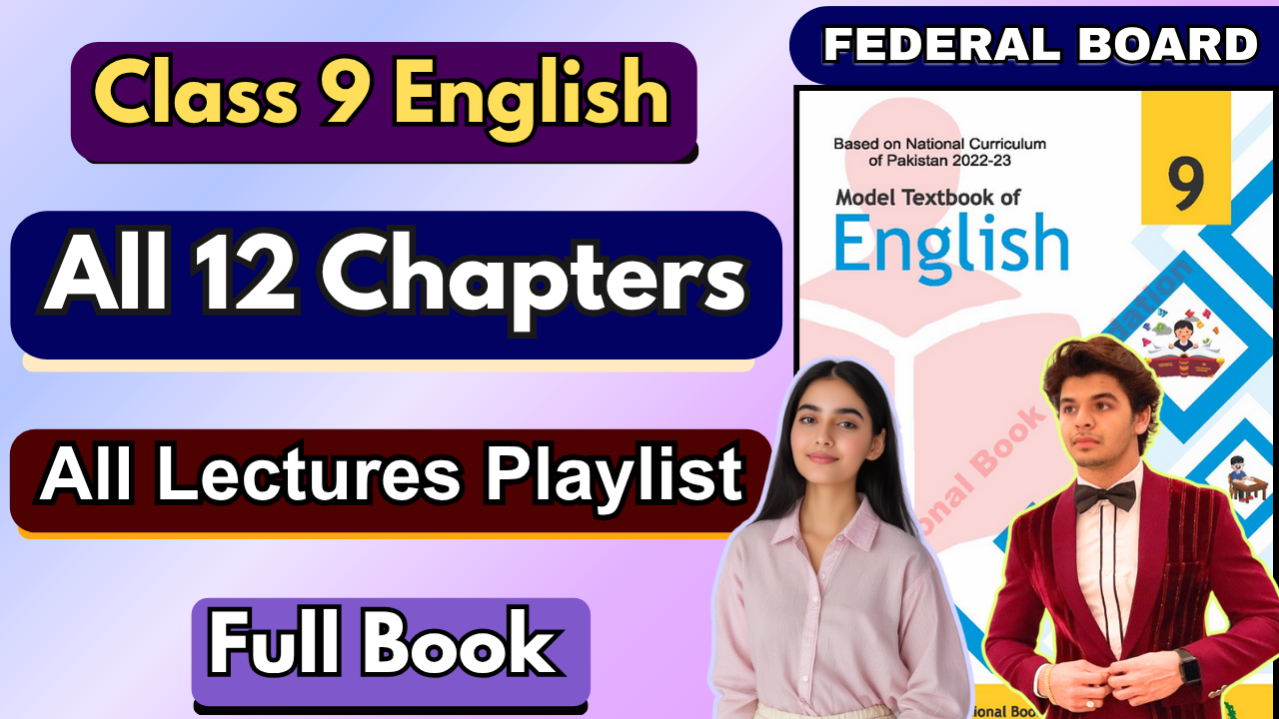

**Glossary:**

**Given below are the difficult words from the unit. Look at their meanings and use these words in your own sentences.**

| **Words** | **Meaning** |
| --- | --- |
| scythe | sickle, cutter |
| fay | fairy |
| elf | imp, dwarf, fairy |
| idle | lazy, indolent |
| earnest | sober, solemn |
| swale | ditch, a low tract of moist or marshy land |
| feeble | weék, delicate |
| orchises | a flowering plant |
| spike | thorn, spine |
| hay | fodder, feed |

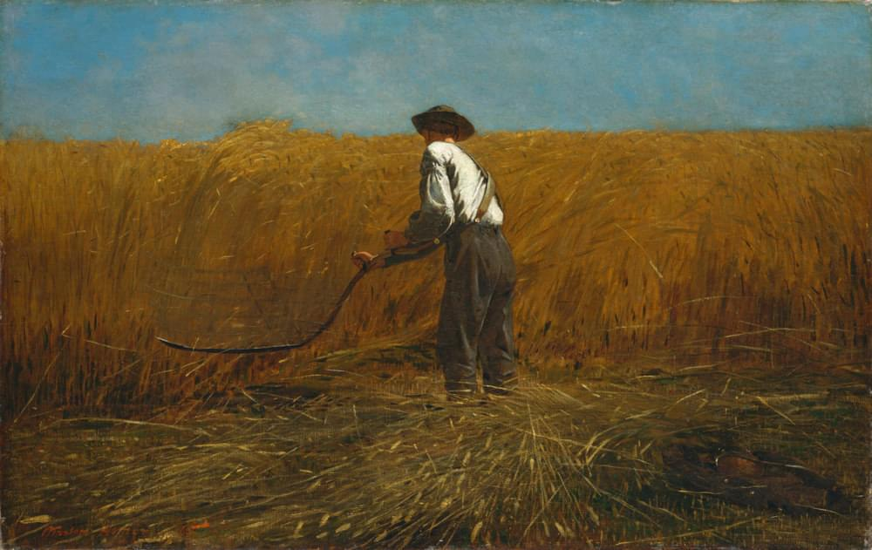

The following are the sentences for the above mentioned words:

1. **Scythe** – The farmer swung his scythe rhythmically, cutting the tall grass at dawn.
2. **Fay** – In the misty forest, the old legend spoke of a gentle fay who protected lost travelers.
3. **Elf** – The little elf hid behind the mushrooms, watching the children play.
4. **Idle** – Don’t remain idle when there’s important work to be done.
5. **Earnest** – She made an earnest effort to complete the project before the deadline.
6. **Swale** – After the rain, water collects in the swale between the two hills.
7. **Feeble** – His voice grew feeble after hours of speaking to the crowd.
8. **Orchises** – The meadow was dotted with bright pink orchises swaying in the breeze.
9. **Spike** – The cactus had a sharp spike that pricked his finger when he touched it.
10. **Hay** – The horses munched happily on the fresh hay piled in the stable.

**Reading and Critical Thinking Skills**

**A. Reading Comprehension Questions:**

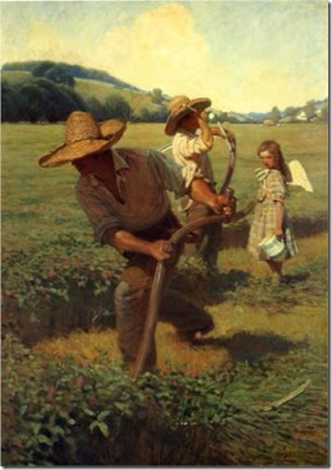

## Q1: Who is whispering to the ground?

## Ans. The scythe is whispering to the ground as it moves through the grass.

## Q2: What was whispered according to the poet?

## Ans. The whisper was something about the heat of the sun, the sound of labor, and the satisfaction of simple, honest work.

## Q3: Enlist poetic devices used in the poem.

**Ans.**

* **Imagery:** "Bright green snake" (visual), "heat of the sun"
* **Personification:** The scythe whispering.
* **Alliteration:** "Sweetest dream that labor knows."

## Q4: According to the poet, what is “the sweetest dream that labor knows”?

## Ans. The satisfaction and fulfillment that comes from honest, meaningful work.

## Q5: What is the central idea of the poem?

## Ans. The poem reflects the beauty of hard work and its connection to nature, emphasizing the joy and simplicity found in honest labor.

## Q6: What is the tone and theme of the poem?

**Ans.**

* **Tone:** Reflective and meditative.
* **Theme:** The value of simplicity, the dignity of labor, and the connection between humans and nature.

# Grammar Questions

## Exercise: Put the verb into the correct tense form.

1. We can go out now. It **is not raining** (not/rain) any more.

**Answer:** It **is not raining** anymore.

1. Ali **is waiting** (wait) for me when I **arrive** (arrive).

**Answer:** Ali **is waiting** for me when I **arrive**.

1. I **am getting** (get) hungry. Let’s go and have something to eat.

**Answer:** I **am getting** hungry.

1. What **do you do** (you/do) in your spare time? Have you got any hobbies?

**Answer:** What **do you do** in your spare time?

1. My brother usually **phones** (phone) me on Fridays, but he **did not phone** (not phone) me last Friday.

**Answer:** My brother usually **phones** me, but he **did not phone** me last Friday.

1. I’m looking for Arham. **Have you seen** (you/see) him?

## Answer: Have you seen him?

1. a. When I last saw you, you **were thinking** (think) of moving to a new flat.

**Answer:** You **were thinking** of moving.

b. That’s right, but in the end, I **decided** (decide) to stay where I was.

**Answer:** I **decided** to stay.

1. What is that noise? What **is happening** (happen)?

**Answer:** What **is happening**?

1. It’s usually dry here at this time of the year. It **does not rain** (not/rain) much.

**Answer:** It **does not rain** much.

1. Yesterday evening, the phone **rang** (ring) three times while we **were having**

(have) dinner.

**Answer:** The phone **rang** three times while we **were having** dinner.

**Verbals**

Verbals are words formed from verbs but used as **nouns**, **adjectives**, or **adverbs** instead of as action words. The three main types of verbals are **gerunds**, **infinitives**, and **participles**.

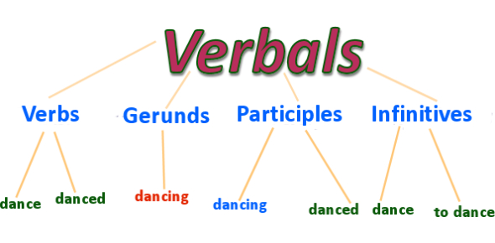

#### 1. Gerunds

* **Definition:** A gerund is the **-ing** form of a verb that functions as a **noun** in a sentence.
* **Usage:** It can act as a subject, object, or complement.
* **Examples:**
  + **Swimming** is good exercise. *(subject)*
  + She enjoys **reading** novels. *(object)*
  + His favorite hobby is **painting**. *(complement)*

#### 2. Infinitives

* **Definition:** An infinitive is the **base form of a verb** usually preceded by the word **“to.”** It can act as a **noun**, **adjective**, or **adverb**.
* **Usage:** Infinitives often express purpose, intention, or potential action.
* **Examples:**
  + I want **to learn** French. *(noun – object)*
  + She has a book **to read**. *(adjective – describes the book)*
  + He came **to help** us. *(adverb – shows purpose)*

#### 3. Participles

* **Definition:** Participles are **verb forms** used as **adjectives** to describe nouns or pronouns.
* There are **two types:**
  + **Present participle:** ends in **-ing**
  + **Past participle:** usually ends in **-ed**, **-d**, **-t**, **-en**, or **-n**
* **Examples:**
  + The **crying** baby needed attention. *(present participle)*
  + The **broken** window was repaired. *(past participle)*
  + The **running** water sounded peaceful. *(present participle)*

| ***Type of Verbal*** | ***Form*** | ***Function*** | ***Example*** |
| --- | --- | --- | --- |
| ***Gerund*** | *Verb + ing* | *Acts as a* ***noun*** | ***Dancing*** *makes me happy.* |
| ***Infinitive*** | *to + Verb* | *Acts as a* ***noun****,* ***adjective****, or* ***adverb*** | *She likes* ***to sing****.* |
| ***Present Participle*** | *Verb + ing* | *Acts as an* ***adjective*** | *The* ***shining*** *stars looked beautiful.* |
| ***Past Participle*** | *Verb + ed/en/n* | *Acts as an* ***adjective*** | *The* ***fallen*** *leaves covered the ground.* |

**Exercise: Identifying Verbals**

For each of the following sentences, decide if the word or phrase in bold is a **participle**, a **gerund**, or an **infinitive**.

1. The children's **singing and laughing** woke me up.

**Answer:** Gerund

1. Jenny likes **to dance** in the rain.

**Answer:** Infinitive

1. There are many ways of **breaking** a heart.

**Answer:** Gerund

1. A **broken** heart will mend over time.

**Answer:** Past Participle

1. Happiness is having a large, **loving, caring**, close-knit family in another city.

**Answer:** Gerund

1. I believe that **laughing** is the best calorie burner.

**Answer:** Gerund

1. I don’t want **to achieve** immortality through my work. I want **to achieve** it by not dying.

**Answer:** Infinitive

1. He escaped away in the waiting car.

**Answer:** Gerund

1. It is not enough **to succeed**. **Answer:** Infinitive
2. **Hunting** dogs are called hounds.

**Answer:** Gerund

**Poetic Devices**

Poetic devices are techniques poets use to enhance the meaning, sound, and emotional impact of their poems. These devices help express feelings vividly, create rhythm, and make the language more powerful and memorable. They include figures of speech, sound patterns, structural elements, and imagery that bring depth and beauty to poetry. By using poetic devices, poets engage readers’ senses and imagination, turning simple words into art.

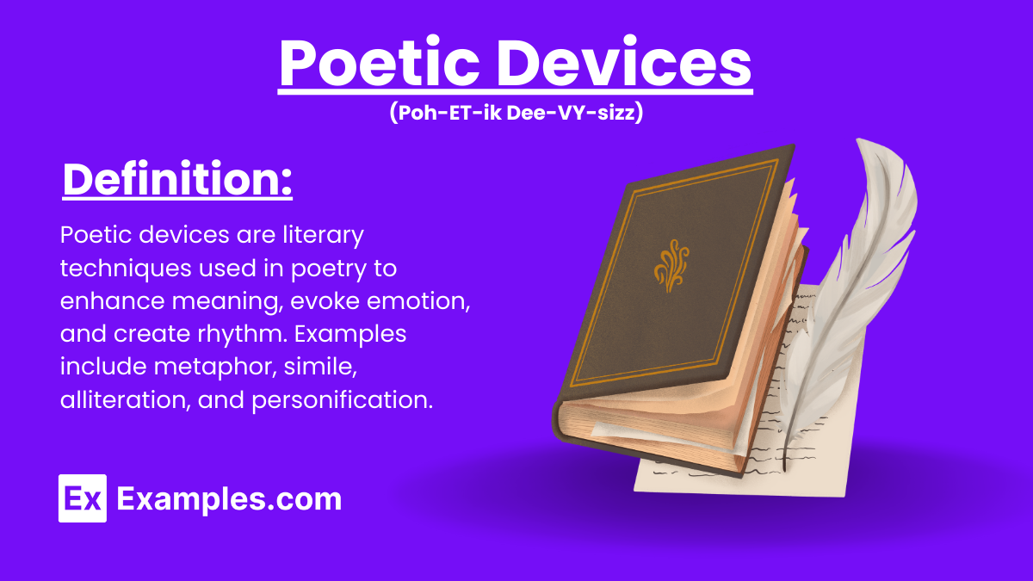

| **Poetic Device** | **Definition** | **Example** |
| --- | --- | --- |
| **Simile** | Comparison between two things using “like” or “as.” | “Her smile was **as bright as the sun**.” |
| **Metaphor** | Direct comparison without using “like” or “as.” | “Time is a **thief**.” |
| **Personification** | Giving human qualities to non-human things. | “The **wind whispered** through the trees.” |
| **Alliteration** | Repetition of the same consonant sound at the beginning of words. | “**Peter Piper picked** a peck of pickled peppers.” |
| **Assonance** | Repetition of vowel sounds within words. | “The **rain in Spain** falls mainly on the plain.” |
| **Imagery** | Use of vivid language that appeals to the senses. | “The **crimson sunset** bathed the sky in gold.” |
| **Onomatopoeia** | Words that imitate natural sounds. | “The bees **buzzed** near the flowers.” |
| **Hyperbole** | Exaggeration for emphasis or effect. | “I’ve **told you a million times**.” |
| **Rhyme** | Repetition of similar sounds at the end of lines. | “The cat sat on the **mat**.” |
| **Enjambment** | Continuation of a sentence beyond a line or stanza. | “The sun rose over the hill / And painted the sky in hues of red.” |
| **Symbolism** | Use of an object or word to represent a deeper meaning. | “A **dove** symbolizes peace.” |
| **Repetition** | Repeating words or phrases for emphasis. | “**Alone, alone**, all, all alone.” |
| **Oxymoron** | Combination of opposite terms. | “**Bittersweet** memories.” |
| **Irony** | Expression of meaning opposite to the literal one. | “A fire station **burning down**.” |

**Writing**

**a. Paraphrase the given stanza.**

There was never a sound beside the wood but one,

And that was my long scythe whispering to the ground.

What was it whispered? | knew not well myself;

Perhaps it was something about the heat of the sun

Something, perhaps, about the lack of sound—

And that was why it whispered and did not speak.

**Ans.** There was no sound in the woods except one—the soft whisper made by the poet’s long scythe as it moved over the grass. The poet wonders what the scythe was trying to say, but he cannot clearly tell. Maybe it murmured about the warmth of the sun or the deep stillness around—and perhaps that is the reason it only whispered quietly instead of speaking aloud.

